Marmara Üniversitesi Mühendislik Fakültesi
Elektrik-Elektronik Mühendisliği

Laboratory Manual

EE 3011

Electronics I

Experiment (3)
Simulation of Diode Circuits using LTspice

Mehmet Ali Kamalak
150720062

Spring 2024

Objectives
Experiment (3)
Simulation of Diode Circuits using LTspice

- To study the IV characteristics of a standard diode (1N4001) by simulation.
Page2
- To simulate simple DC and AC diode circuits.

Pre-lab Work
Analyze the circuits below using the constant voltage diode model (𝑉_{𝐷0}=0.7 V).

Circuits
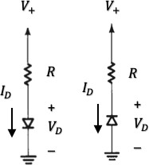
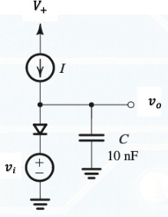
Forward Backward
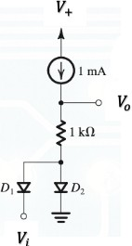Figure 1: Diode IV Circuit. Figure 2: DC diode Circuit. Figure 3: AC Diode Circuit

Procedure
Part (1): Diode IV Characteristics.

- Connect the circuit in figure 1 (Forward). Use the circuit elements values given by the lab instructor. 𝑉! is a DC voltage source.
- Use the DC Sweep function and simulate the response of the circuit to produce the IV curve
of the diode (𝐼_{𝐷} vs. 𝑉_{𝐷}). What is the 𝑉_{𝐷#} of this diode? Record the results in table 1.
- Repeat for the backward circuit. What is the 𝑉$# of this diode? Record the results in table 1.
- Vary the value of 𝑅 and repeat the procedure observing the effects (if any).

Part (2): DC Diode Circuit.
- Connect the circuit in figure 2. Use the circuit elements values given by the lab instructor. 𝑉!
and 𝑉_{i} are fixed DC voltage sources.
- Simulate the circuit. Which diode is ON and which is OFF?

Page3
- With 𝑉_{i} fixed, vary the value of 𝑅 and repeat step 2 observing the effects on the diodes switching. Record your results in table 2.
- With 𝑅 fixed, vary 𝑉_{i} between the range -10 to +10 V and plot the output characteristics curve (𝑉_{𝑜} vs. 𝑉_{i}).
Part (3): AC Diode Circuit.
- Connect the circuit in figure 3. Use the circuit elements values given by the lab instructor. 𝐼 in the circuit is a DC current source and 𝑣_{i} is a sinusoidal signal with small amplitude (less than 10 mV) and a frequency 𝑓.
- Simulate the circuit and plot the waveforms for 𝑣_{i} and 𝑣_{𝑜} (versus time).
- From the plot in step 2, find the phase shift between 𝑣_{i} and 𝑣_{𝑜}. Record the result in table 3.
- Vary 𝐼 and observe the phase shift between 𝑣_{i} and 𝑣_{𝑜} at each setting. Record your results in table 3. Find a value of 𝐼 that gives a phase shift of ±45º?

Results and Analysis
Part (1): Diode IV Characteristics.

Table 1. Diode IV Curve.

𝑅 (kΩ) | Simulation  𝑉_{𝐷0} (V) | Data sheet  𝑉_{𝐷0} (V) | Simulation  𝑉_{Z0} (V) | Data sheet  𝑉_{Z0} (V)
1 | 0.7 | 0.72 | - 0.7 | - 0.72
10 | 0.7 | 0.72 | - 0.7 | - 0.72
100 | 0.7 | 0.72 | - 0.7 | - 0.72

- Comment on the results in table 1.

The change in resistance values ​​does not cause any change in voltage values.

- Do the IV curves that you obtained resemble the standard diode characteristics? Explain.

Yes, the diode behaves like an open circuit up to a certain voltage value and does not pass current. Then, after a certain voltage value, it acts like a short circuit and starts to flow current.
Page4
Part (2): DC Diode Circuit.

Table 2. Simulated DC results.

𝑅 (kΩ) | Diode 1 (ON/OFF) | Diode 2 (ON/OFF) | 𝑉₀ (V)
1 | OFF | ON | 0.03
10 | OFF | ON | 0.042
100 | OFF | ON | 0.131
1k | OFF | ON | 1

- Comment on the results in table 2.

As the resistor value increases, the output voltage also increases.

- Comment of the output characteristics curve.

The output voltage continues to increase exponentially as long as the resistance value continues to increase

Part (3): AC Diode Circuit.

Table 3. Simulated AC results.

I (mA) | Phase shift
1 | 180 µs
10 | 3.8 µs
100 | 1.3 µs
1000 | 0.1 µs
10000 | 0
100000 | 0

Page5
- Which value of 𝐼 gives a phase shift of ±45º?

It was not shown how to find phase shift in the lab and I cannot answer this question because I cannot find it on the internet.

- Explain the output waveform.

As the current value increases, the input and output graphs become more similar to each other and the phase shit between them decreases.

- Comment on the circuit output characteristics curve.

As you increase the current value, the sine wave in the received sine signal becomes smoother and more distinct.
Page6

Lab Assignment

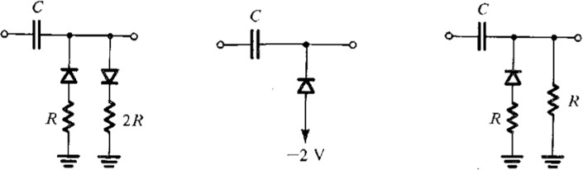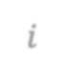
𝑣$
𝑣_{𝑜}
𝑣$
𝑣
𝑜
𝑣$
𝑣_{𝑜}

Circuit 1 Circuit 2 Circuit 3

- The lab instructor will assign one circuit to you with appropriate elements values. All diodes are 1N4001 model.
- Connect the circuit using the circuit elements values given by the lab instructor. 𝑣_{i} is a periodic signal as shown below.
- Simulate the circuit observing the waveform at the output (𝑣_{𝑜}).
- By varying the amplitude of the input signal from 0 to 15 V, produce the transfer function curve of this circuit at the frequency given below.
- Fix the amplitude at the value below but vary the signal period from 0.1 to 10 ms and make observations regarding the circuit operation.
- Study the effect of the elements 𝑅 and 𝐶 (independently) on the operation of the circuit. Give conclusions.
- What application can this circuit be good for? Explain.

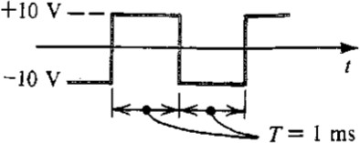
𝑣$

Name | Mehmet Ali Kamalak
ID | 150720062
Section | 1

Page7

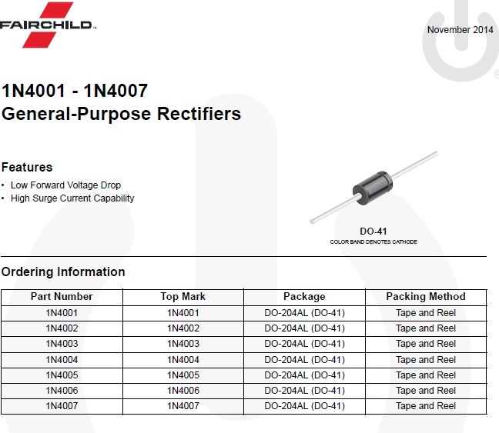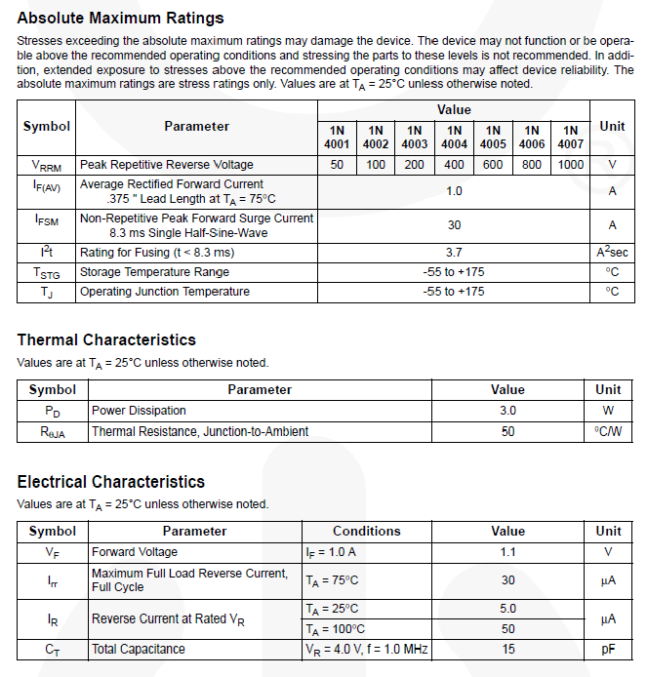

Page8
Lab Assigment:

I chose the second circuit.
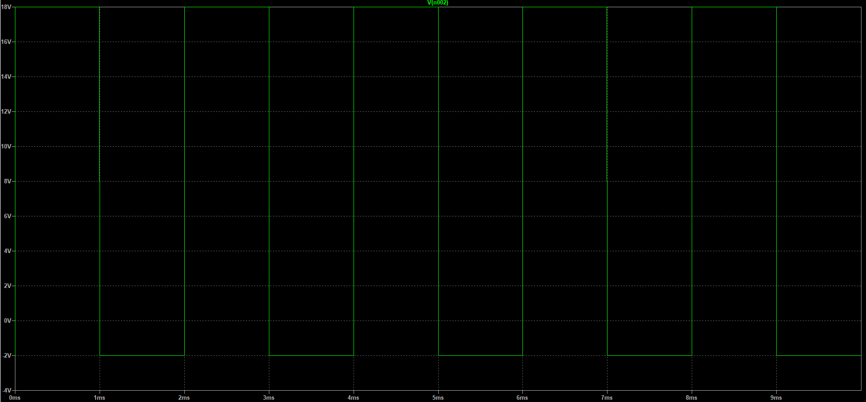

I cannot change R values ​​as there is no resistor in the circuit. I just change the C values ​​of the capacitor

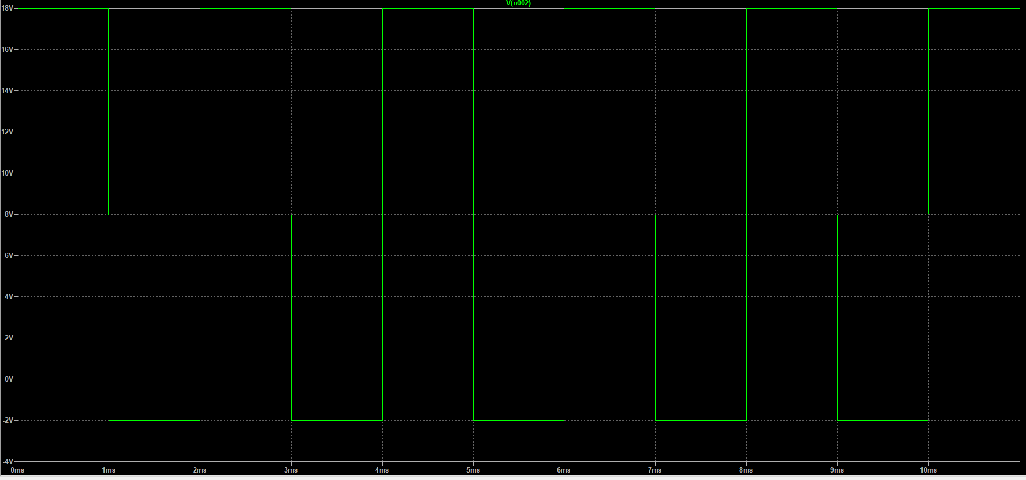
10 µF

Page9
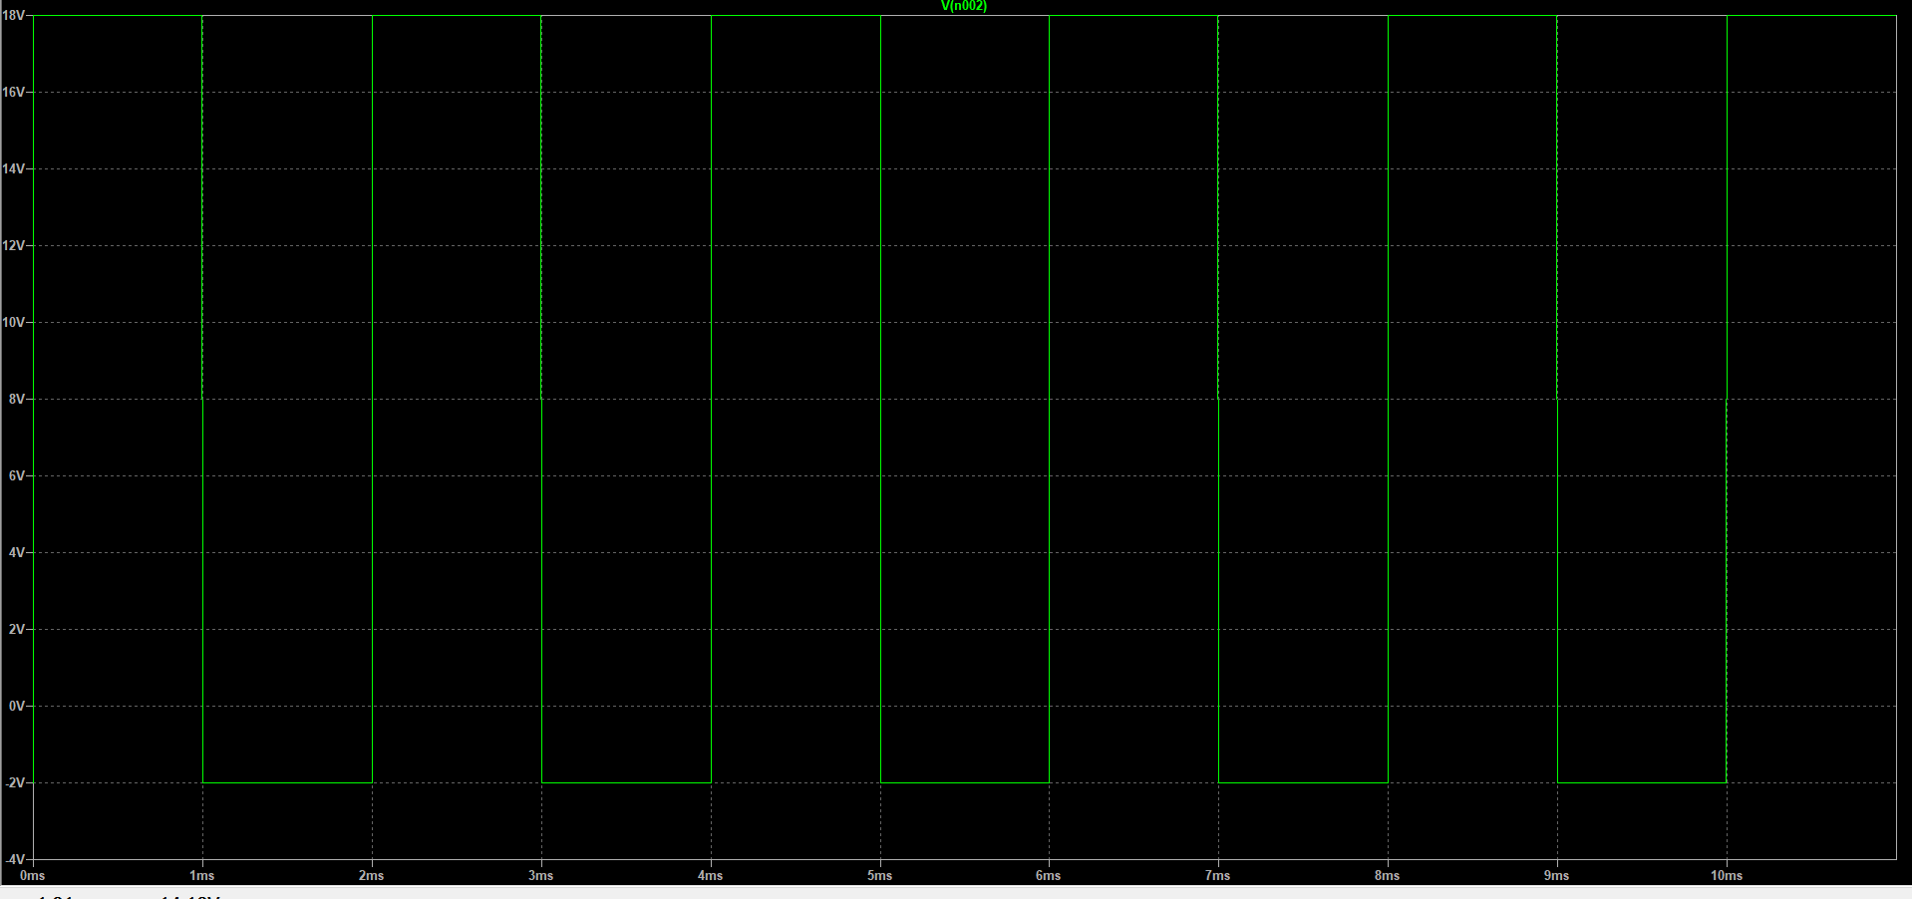
100 µF

When I change the C values, there is no change in the graphics.

